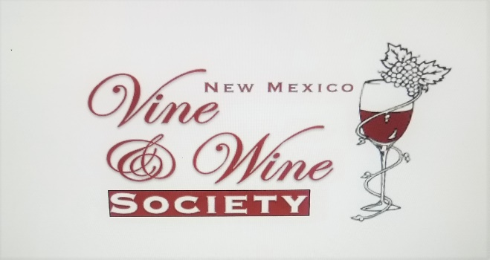NEW MEXICO VINE AND WINE SOCIETY, INC.

MEMBERSHIP APPLICATION

New website soon to be unveiled

The New Mexico Vine and Wine Society is a non-profit organization which promotes information exchange among amateur and commercial grape growers, wine makers and wine enthusiasts. There are four chapers, the Middle Rio Grande Chapter, the Northern Rio Grande Chapter, the Southern Rio Grande Chapter and the Tularosa Basin Chapter. The New Mexico Vine and Wine Society sponsors the annual State Fair Wine Judging along with other regional educational and social events.

ANNUAL DUES ARE $20.00 PER PERSON FOR 1 YEAR FROM AUGUST TO AUGUST

Name: ____________________________________________

Address:___________________________________________

City:____________________State:_________ Zip:_________

DATE:__________ Phone:_______________Cell:___________

Email address________________________________

Grape grower?_____Winemaker?_____ Enthusiast?_________

Payment by check or cash. Make checks payable to the New Mexico Vine and Wine Society or NMV&WS (20$ per person) If needed mail checks and application form to: NMV&WS, PO BOX 26751, Albuquerque, NM 87125